**Brooklyn torah gazette**

**For parshas acharei mos 5779**

Volume 3, Issue 35 (Whole Number 131) 29 Nissan 5779/ May 4, 2019

**Printed L’illuy nishmas Nechama bas R’ Noach, a”h**

For a free subscription, please forward your request to [***keren18@juno.com***](mailto:keren18@juno.com)

**Rabbi Recounts the Horrific Poway Chabad House Shooting**

**By Tzemach Feller**

***‘My life was spared for a reason’***

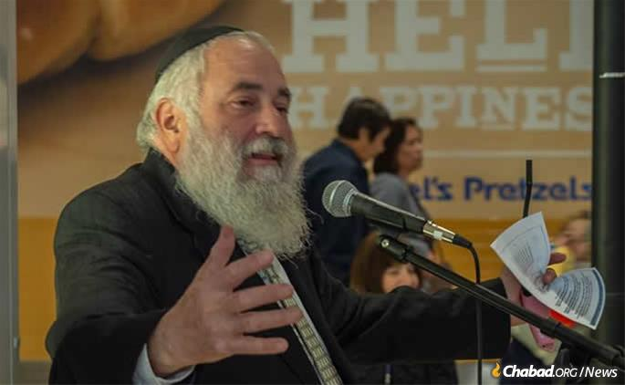

**Rabbi Yisroel Goldstein speaks at a Chabad of Poway Chanukah event in December.**

“It’s a miracle that I’m alive and talking to you,” Rabbi Yisroel Goldstein tells [Chabad.org](http://www.chabad.org/news" \t "_blank)from his hospital room, where he was recovering from the gunshot wounds he suffered during the t[errorist attack at Chabad of Poway](https://www.chabad.org/news/article_cdo/aid/4365316/jewish/One-Dead-Three-Injured-in-Shooting-at-Chabad-Synagogue-Near-San-Diego.htm) on the morning of April 27. “The shooter was 15 feet away from me.”

About 50 congregants filled the benches at Chabad of Poway, observing the final day of Passover, which includes the *[Yizkor](https://www.chabad.org/library/article_cdo/aid/371509/jewish/Yizkor-The-Memorial-Prayer.htm)* [prayer](https://www.chabad.org/library/article_cdo/aid/371509/jewish/Yizkor-The-Memorial-Prayer.htm) commemorating loved ones. Goldstein, who is the senior rabbi at Chabad of Poway, had stepped out of the sanctuary to prepare for the [haftorah](https://www.myjewishlearning.com/article/haftarah/" \t "_blank). In the lobby, he saw Lori Gilbert-Kaye. “What time is *Yizkor*?” she asked the rabbi. Kaye was looking forward to reciting the prayer in memory of her late mother. Her daughter Hannah, a UCLA student, had flown to Poway to be with her mom during the poignant, often emotional service. Goldstein told her that it was called for 11:30 a.m., just a few minutes away, and wished her a happy Passover. Then he turned to wash his hands.

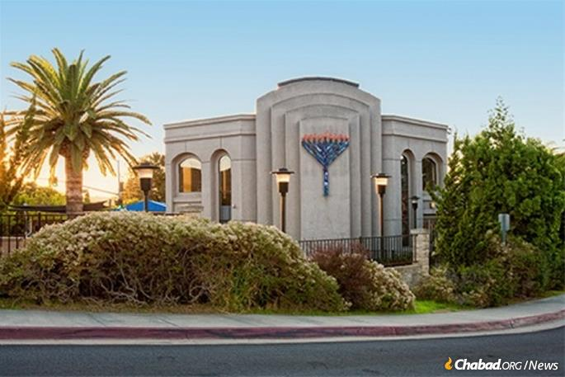

**The Chabad of Poway synagogue**

A sudden, loud bang startled him. When he turned back around, Kaye was prostrate on the lobby floor, and the terrorist’s rifle was pointed right at him. “I locked eyes with him. He was at the door to the sanctuary,” said Goldstein. “That’s when he fired, blowing off my right index finger and severely injuring my left index finger.”

Grabbing a towel to stanch the flow of blood, Goldstein ran towards a group of children standing nearby. He was joined by a guest named Almog Peretz, a former Israeli soldier who was visiting family from his home in Sderot, Israel, where he is no stranger to terrorist attacks. Disregarding the danger to their own lives, they whisked the children to safety. The gunman fired again and again, at some point striking Peretz in the leg and injuring Peretz’s niece, 8-year-old Noya Dahan, who took fragments to the leg and near her eye.



**Noya Dahan, 8, was injured in the attack.**

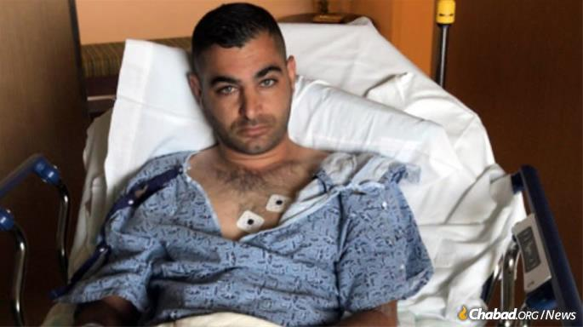

**Almog Peretz was shot while rushing**

**a number of children to safety.**

As congregants ran for their lives, two ran in the opposite direction — directly towards the shooter. Oscar Stewart, a longtime congregant and U.S. military veteran, charged the terrorist. At that time, the shooter’s weapon jammed, and he turned tail and fled the building. A moment later, JonathanMorales, an off-duty U.S. Border Patrol agent, fired four rounds, striking the gunman’s vehicle.

Morales recently discovered that he was Jewish, and began his journey back to his roots under the tutelage of Rabbi Goldstein, even attending this year’s International Conference of Chabad-Lubavitch Emissaries in New York. He had made the two-hour trip from his home in El Centro, Calif., to join the Passover services at Chabad. Now, his heroic actions—and those of Goldstein, Peretz, Stewart and others—helped save countless lives. “This could have been a bloodbath,” said Goldstein. “I hope our actions helped prevent a worse loss of life.”

“Once I knew the shooter was away, I ran back to the lobby,” Goldstein continues. He beheld a grisly sight. Lori Kaye was unresponsive, and her husband, a doctor, had fainted from shock and was slumped beside her. Their daughter hovered over them, overcome with grief. “It felt like forever before the paramedics arrived. They had to wait for the police to give them the all-clear before entering the building.”

**The Teachings and Example of the Rebbe**

As police and paramedics evacuated the congregants and triaged the injured, Goldstein thought of the teachings and example of the [Rebbe—Rabbi Menachem M. Schneerson, of righteous memory](https://www.chabad.org/therebbe/default_cdo/jewish/The-Rebbe.htm" \l "utm_source=domain&utm_medium=domain&utm_campaign=therebbe.org)—in the face of terror, and got up on a chair outside the sanctuary to address his congregation, beginning with the traditional [Priestly Blessing](https://www.chabad.org/library/article_cdo/aid/894569/jewish/The-Priestly-Blessing.htm): “May G‑d bless you and guard you. May G‑d shine His countenance upon you and be gracious to you. May G‑d turn His countenance toward you and grant you peace.”

As his hands bled profusely, a shaken Goldstein continued instinctively, resolutely relaying some of what he had learned from the Rebbe. “In the face of darkness and evil, we must not back down but redouble our efforts,” he said. Quoting a passage from the Passover Seder liturgy, “In every generation they rise against us to destroy us; and the Holy One, blessed be He, saves us from their hand,” Goldstein spoke of the unity and perseverance of the Jewish people, and finished with a resounding, “Am Yisrael Chai! Nothing will take us down! This is what the Rebbe taught us, this is what we live with. We are going to stand tall, we are going to stand proud of who we are, of our heritage ... and we’re going to get through this.”

“The paramedics wanted to take me to the hospital,” Goldstein relates, but he refused. “Not until everyone is accounted for.” Two children who were missing were soon found. They had run to a neighbor’s house. Satisfied his flock was cared for, Goldstein at last got into the ambulance.

Doctors couldn’t save his right index finger, which had to be amputated. Surgeons spent four hours attempting to save his left index finger, which was also badly injured. All three injured have been released from the hospital, but Goldstein’s road to recovery will be longer. “This will leave emotional and physical scars forever,” he says. “When I look at my fingers, it will remind me of how vulnerable we are, and also how heroic we must be.”

**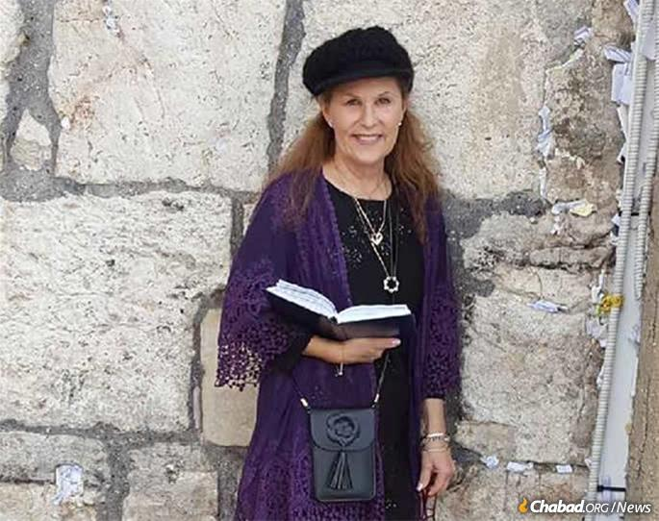**

Lori Gilbert-Kaye, hy”d

As the injured recover, the community mourns the loss of Lori Kaye, whose funeral is scheduled for Monday. Kaye had been a congregant at Chabad of Poway for 25 years. She would bring gifts of *challah* and flowers to people going through a rough time. When a community member was diagnosed with breast cancer, it was Kaye who volunteered to drive her to all of her appointments. “She was all about *chesed*—kindness towards others,” said Goldstein. “She was an activist; a doer. It’s a catastrophe beyond description.”

Despite the heinous attack on his synagogue and on his person, Goldstein’s message is one of hope. “We Jews are happy to be living In the United States, where our freedom to practice our religion is protected. We cannot and will not let terror win. My life was spared for a reason: so that I can continue my 35 years of outreach to Jews in Poway. The Rebbe taught that in the face of darkness and evil we must continue reaching out and inspiring people. Let’s get everyone to synagogue this Shabbat. Let’s show them this will not deter us one step.”

*The funeral of Lori Gilbert-Kaye will took place on Monday, April 29. Chapel Service at Chabad of Poway, 16934 Chabad Way, Poway, CA 92064. Levaya-funeral service at El Camino Memorial, 5600 Carrol Canyon Road in San Diego.*

*Many have asked how they can contribute to help the victims and their families and assist Chabad of Poway get back on their feet. Contributions can be made here:[www.chabadpoway.com/standwithpoway](http://www.chabadpoway.com/standwithpoway" \t "_blank).*

*Reprinted from the April 28, 2019 website of Chabad.Org*

**Rav Elyakim Getzel Rosenblatt, Zt’l: An Appreciation**

**By Rabbi Yair Hoffman**

**[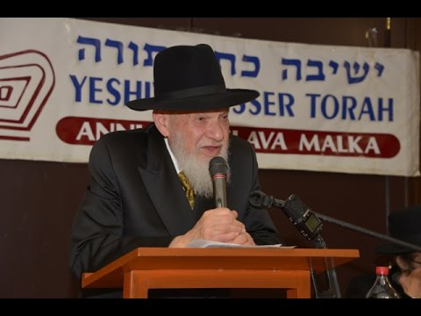](http://d16cunm4ue8a76.cloudfront.net/wp-content/uploads/2019/04/Hoffman-rav-getzel.jpg)**

“Rosh Yeshiva, there is a Jewish fellow who wants to become a reform rabbi. Someone suggested that he attend a yeshiva first. Could he start coming to shiurim here?”

*“Of course! What is the question?”*

“Rosh Yeshiva, there is a Jewish fellow who is kind of involved with the mafia. He wants to start attending our Gemara shiurim. Is it OK if he comes and learns in the yeshiva?”

*“Every neshamah that was at Har Sinai deserves to know of his birthright. Of course, he should come!”*

Both of the above conversations took place within the confines of Yeshiva Kesser Torah of Queens close to three decades ago. I know, because I was the one who posed both of the questions.

Rav Elyakim Getzel Rosenblatt, zt’l, the rosh yeshiva of Yeshiva Kesser Torah of Queens, was a talmid of both Rav Aharon Kotler, zt’l, and Rav Henoch Leibowitz, zt’l. He began learning at BMG in 1951, at the age of 18. At the age of 27, he went to learn under Rav Henoch and remained a talmid of both of them.

Rav Rosenblatt and, yblc’t, his eishes chayil, Rebbitzen Trani, were early pioneers of a unique brand of kiruv. They combined tremendous ahavas Yisrael with warmth, love, delicious meals, hartzige singing, and an in-depth Talmud study for ba’alei teshuvah and those who needed more personal instruction. The thousands of talmidim attest to their success.

As Rav Hershel Welcher, shlita, pointed out in his hesped at the levayah, Rav Rosenblatt, zt’l, and his rebbetzin embodied what Rav Chaim Volozhin’s son writes about his father in the preface to the Nefesh HaChaim:

“For this is all of man. He was not created for himself. Rather to do for others in all that he is capable of doing.”

And the two of them certainly did for others.

Rav Rosenblatt’s talmidim and their children and grandchildren number in the thousands. They have entered and contributed to many Jewish communities. They fill the rosters of yeshivos and Bais Yaakovs across the country and in Eretz Yisrael.

There have been Yeshiva Kesser Torah talmidim who have entered the portals of that remarkable yeshiva and have emerged as roshei yeshiva themselves. Some went on to other great yeshivos as well. A number received semichah from Rav Dovid Feinstein, shlita. Others have gone on to help lead mosdos of Torah in their own right.

What was it about this remarkable man that broke such barriers? What was it about this couple that gave them such clarity of purpose: That we are here to bring people tachas kanfei HaShechinah?

At the levayah, the rosh yeshiva’s brother, Rav Zev Rosenblatt, shlita, mentioned their upbringing in Brownsville, New York, where everyone around them was a survivor of the Holocaust. It was a time when no one had grandparents, and the parents who had come over to America were struggling to survive.

Even as a young man, Reb Elyakim Getzel’s overriding concern was the spiritual growth of his peers. Ever the masmid, ever the ba’al mashpiah, he directed his peers and his younger brother to draw from the life-giving waters of the gedolei Torah who taught shiurim. Whether it was in Yeshivas Chaim Berlin, Telshe, or Lakewood, he would encourage others to attend and make the most of it. They did, and today many of them stand as leading rabbinic personalities.

The influence of Rav Aharon Kotler, zt’l, on his thinking and learning was profound. He carried Rav Aharon’s shmuessen with him until the day he passed away. But perhaps more importantly, he was able to break down Rav Aharon’s incredible mussar insights into manageable and contemporary lessons for his talmidim. He did this for Rav Henoch’s shmuessen as well. Although one would never detect it from the way he carried himself, he was a master of the Slabodka-esque mussar shmuess. He would spend hours over Rav Leib Chasman’s Ohr Yahel, unfolding the subtle differences between the approach of Rav Chasman and that of Rav Aharon in a particular mussar inyan. His love of the Slabodka mehalech of shmuessen permeated his being.

At one point, Rav Rosenblatt decided that he must also learn by Rav Henoch Leibowitz, zt’l, of Yeshiva Chofetz Chaim. He learned there, too, and continued to drink of the well of his beloved Mussar.

Rav Rosenblatt also loved the in-depth unfolding of the steps of the Gemara that Rav Dovid Leibowitz, zt’l, and his son, Rav Henoch, were noted for teaching. What was the movement in the Gemara’s thinking at each point? What was the shift between the hava amina and the maskana? Are there words in the Rishonim that can prove one way or the other? He loved this method of study and taught it to his talmidim.

Rav Elyakim Getzel became a lifelong talmid of Rav Henoch. Eventually, Rav Rosenblatt taught the mechinah shiur in the high school. Rav Dovid Harris, shlita, one of the two concurrent roshei yeshiva of Yeshiva Chofetz Chaim, said at the levaya that Rav Rosenblatt was his ninth-grade rebbe and made a strong impression upon him.

Eventually, Rav Rosenblatt went on to become a rav in the Corona section of Queens. There, he and his rebbetzin continued in their kiruv efforts, forming lifelong relationships. They hosted Shabbos meals replete with incredible food, incredible zemiros, and incredible shiurei Torah.

He looked at his talmidim as family, and they looked at him as a father. He catered the shiurim in the yeshiva toward anyone and everyone who had time to learn. The yeshiva was unique in that there were several hours of shiurim every day where people could pop in and learn Torah in depth. He would meet people in the streets of Kew Gardens Hills or Kew Gardens and remark, “We have a businessman’s special! Come to the yeshiva and learn at the early shiur and then go to work having your daily Gemara shiur!”

They did. The experience made them into bnei Torah. These businessmen talmidim eventually established Torahdik homes themselves and helped create a new generation of bnei Torah.

One talmid remarked, “I lived in KGH from about 2007 through 2012. In 2007, I was just back from yeshiva in Israel and starting law school at St. John’s University. I often found myself in Kesser Torah learning between my law school classes. I got married in 2010 and moved away in the summer of 2012.

“At this point, Rav Rosenblatt was older and had already survived his life-threatening medical incident. On a few occasions, Rabbi Rosenblatt invited me for Shabbos, yom tov, or a Chanukah seudah, and it was at his Shabbos table that I got to observe his ahavas Yisrael. He had the full range of Jews, from non-observant, partially observant, yeshiva bachurim, young marrieds, older singles. He had such a soft and gentle way about him.”

The impact of Rav Rosenblatt, zt’l, and, ybcl’t, his rebbetzin in terms of facts on the ground number in the several-thousands. In Maale Adumim, for example, just one of his talmidim has influenced thousands himself. What better revenge against the tragic desolation that the Nazis, y’s, inflicted upon Klal Yisrael?

Rav Rosenblatt was also a remarkable ba’al menagein. While Rav Rosenblatt was in BMG in Lakewood, Rav Aharon Kotler would enjoy his young talmid’s hartzige singing. The young Reb Elyakim Getzel would also compose his own niggunim. Rav Aharon had a special appreciation for zemiros and niggunim and encouraged his talmidim in that regard.

One day, a former talmid of Rav Aharon, who had initially gone out in the world to bring others tachas kanfei haShechinah, came back to BMG for a Shabbos. He joined the bachurim for the singing of zemiros and naturally wanted to assume his former position of being the ba’al menagein at the seudah. Rav Aharon shook his head, “No.”

He then pointed to Rav Elyakim Getzel to lead it. The former ba’al menagein went on to make a major impact in the Jewish music world. Rav Rosenblatt took Rav Aharon Kotler’s approval and encouragement of his niggunim and singing as an inspiration to incorporate music and zemiros as part-and-parcel of the approach one should have to chinuch and kiruv. Eventually, Rav Rosenblatt put out two albums of his niggunim.

Rav Rosenblatt thought deeply about everything that he did. He decided, after much thought, that to best attract talmidim he would reconfigure the method of in-depth learning that was taught in his yeshiva. The new mehalech was to learn the halachah in the Rambam.

Whether it would be in Shabbos or Berachos or one of the other sections of the Yad HaChazakah depended on what was being learned. Then, he and his talmidim would carefully learn the Gemaras that the halachah was based upon. He would then trace it through the Rambam, Rosh, Kitzur Piskei HaRosh (written by the Tur), Tur, Beis Yosef, and Shulchan Aruch.

To Rav Rosenblatt, the Shulchan Aruch was an amalgamation of the various thoughts of the Rishonim where Rav Karo incorporated their wording. He also loved the Frankel edition of the Rambam and loved exploring from where exactly the Rambam had derived his rulings. He would carefully learn through all of these sources and involved his talmidim. His clarity was remarkable and he was able to get his talmidim to provide their own in-depth and thought-provoking explanations. The talmidim responded beautifully. They were genuinely contributing to cutting-edge, deep Talmudic thought!

This respect for his talmidim not only emerged from his shiurim; it was part of his daily interaction with others. He would call a talmid “Rabbeinu.” This was because he meant it; such was his anivus.

Rav Rosenblatt believed in people. This was another trait that was unique about him. The encouragement and trust that he placed in people was essential to their growth. A talmid would think, “Wow! The rosh yeshiva places such trust in me!” And the talmid would strive to live up to it. Invariably, that talmid did. Rav Rosenblatt had an understanding of the importance of building self-esteem in others that was most profound and essential in his success.

Once, one of his talmidim was killed in a horrific tragedy. The incident affected him deeply and he spent much time on the phone with the talmid’s mother comforting her, as this talmid was her only child. His talmidim were family.

In his divrei Torah, he would always focus on pshat. But he also explored other areas of thought. One talmid recalled how he loved creative approaches to Torah and having genuine fun with Torah. Another one of Rav Rosenblatt’s trademarks was, “This is the simple pshat. The chassidishe Torah’leich say …”

And then there were the parashah sheets. When I was first hired as the mashgiach and a rebbe at Yeshiva Kesser Torah, I was enamored at both the ease of accessibility of the depth of the Mussar shmuessen. How lucky were the talmidim of Yeshiva Kesser Torah!

Here was a clear and depth-filled exposition of both Rav Aharon Kotler’s and Rav Henoch Leibowitz’s approaches to a Mussar inyan, including other gedolei haMussar. It was kind of like the first Schottenstein ArtScroll Gemara for Mussar. I suggested to Rav Rosenblatt that the shmuessen be written up and distributed in shuls and yeshivos. He took up the suggestion, and for the next number of years, many hours were spent each week editing, re-editing, and editing further.

The printed Mussar shmuessen became a huge success. Each week, dozens of shuls and yeshivos requested to be added to the distribution network. Distributors were hired. Letters of appreciation came in. Letters arguing points came in. Eventually, they were put into sefer form.

Rav Rosenblatt, zt’l, would sometimes throw convention to the wind in his ardor to bring out a point. Rav Rosenblatt wanted certain ideas emphasized in the written word as well that can be emphasized in the spoken word through voice modulation. But how to do that in the written word? Rav Rosenblatt decided to use the bold function of the computer liberally.

“But Rosh Yeshiva, this is not done.”

“But why not?” he would respond. “If it can help bring across a point of Torah thought, then let us throw convention to the wind.”

For many years later, he would show me other sefarim in lashon ha’kodesh in which a particular page would have five or six lines of bold font.

Eventually, the printed shmuessen would regularly incorporate one phrase that would convey a question that the gedolei Mussar would ask on that week’s parashah.

“This is mystifying” would invariably appear in each sheet. It became a catchphrase, like product branding or a trademark. It eventually brought one struggling former talmid back to yeshiva and the Torah way of life.

Oh, and what ever happened to the two people mentioned at the beginning of this appreciation? One went on to build a beautiful Torahdik mishpachah and became a pillar in his community. The other, the wealthy “connected” person, learned for several years at the yeshiva and looked upon Rav Rosenblatt as his own rosh yeshiva.

He devoted his life to helping other mosdos of Torah. That talmid was so taken by the story of the Mirrer Yeshiva’s salvation through Shanghai, China, that he once approached Rav Kalmanovitch, zt’l, about the possibility of making a movie about it. Rav Kalmanovitch, zt’l, responded in the negative, because he knew that in order to make a movie popular, there would have to be scenes in it that are incompatible with what Torah is all about. The talmid dropped the project.

There is no question that the world is a different place without Rav Rosenblatt. As a consolation, his shmuessen can still be heard on [TorahAnytime.com](http://torahanytime.com/). They can be read in Yeshiva Kesser Torah’s parashah sheets. His niggunim can be heard on Shaar HaNeginah tapes and CDs. But there is no replacement of this remarkable individual who impacted such a large section of Klal Yisrael.

*Reprinted from the April 4, 2019 edition of the 5TJT (Five Towns Jewish Times.)*

**The Poor Man’s Sad Mistake**

**By David Bibi**

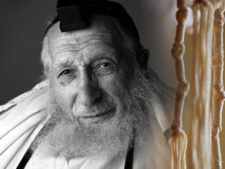 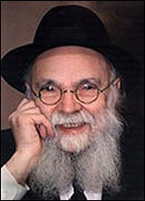

**Rabbi Chaim Pinchas Scheinberg and Rabbi Avrohom Pam**

The Ramban writes that when a person offers an animal sacrifice [for a kapparot, atonement], he is really supposed to think that the slaughtered animal on the mizbayach should really be him. As it is with so many Mitzvot, the Torah desires one’s heart, not just the hollow act of bringing a sacrifice. The Torah wants the intent of what he is doing to penetrate into the deepest recesses of a person’s personality. The Torah is interested in the person achieving the feeling of what bringing a korban is supposed to be about.

When a wealthy person plunks down his credit card to pay for his expensive offering of a cow, he has the attitude that “I certainly did my share. This animal cost me big big bucks! What more do You want?”

Therefore, he lacks the requisite humility appropriate for one who is supposed to be seeking atonement. But the poor man knows that all he is bringing is a minimal korban – a little flour, a little oil. He knows that he does not earn atonement for the few pennies he spent.

He understands that his offering is just symbolic and is supposed to represent a deeper emotion that emerges from the recesses of his soul. He puts his heart and soul into the offering because he clearly realizes that it is not the flour and the oil that will gain him atonement.

When a person is poor and cannot afford to buy his way out of his iniquity, the only thing he has going for him is his nefesh – his soul. Therefore, he puts his heart and soul into the offering. The Torah highlights this idea by the use of the word nefesh in connection with the flour offering.

It should seem obvious to us that if a wealthy man wants to “cheap out” and he brings the offering of a poor man than his offering should be rejected. In fact, the rabbis teach us in the Talmud that if a wealthy man were to bring the Korban designated for a poor man, he has not fulfilled his obligation. Furthermore, it is considered as if he has brought chullin, unconsecrated flesh, in to the Azarah, Sanctuary, which is a serious violation.

Rabbi Scheinbaum quotes the Chafetz Chaim, zl, who derives from here that in contemporary times, when we do not have a Bet Hamikdash, we contribute charity, in lieu of certain sacrifices. Hence, just as in ancient times a wealthy man could not absolve himself with a korban reserved for a poor man, so, too, a wealthy man may not acquit himself with the sedakah that a poor man would normally give. One must give in consonance with what one has. To give based upon the financial status of one who has much less than he does, would be gross chutzpah.

With all this in mind Rabbi Farhi brought up a question at breakfast on Shabbat. What happens if a poor man who really cannot afford more than the meal offering, puts himself out borrowing beyond his means to give something better? Is that offering accepted? Shouldn’t he be looked at as a person overcome by such love of Hashem that he wants to do even the impossible? Should he be blessed for his efforts?

The overwhelming response was that it was a good thing for someone to try to do more.

But what do our rabbis say? The question is asked about a poor man who squeezes out every penny that he possesses in order to bring a korban fit for a wealthy man? Has he fulfilled his obligation?

Rabbi Scheinbaum quotes the Sefer HaChinuch (123) cited by Rav Pam who says no. He explains that since Hashem has taken pity on the poor man and has permitted him to satisfy his obligation with a tenth-eiphah of flour, it is improper for him to overextend himself by bringing more than he can afford.

Rav Pam explains that a person must learn to live within his means. When one spends more than he can afford, he flirts with disaster. Eventually, he will be compelled to satisfy his desire for spending by doing something illegal. One who habitually seeks more than he can sustain has a habit that will most likely destroy him.

Rav Pam, z’sl, feels that the Sefer HaChinuch's remarks--written in a different time and addressed to a different generation-- still carry tremendous weight today. We should underscore their relevance for contemporary society. American Jews have enjoyed a sense of prosperity and standard of living unlike any generation preceding us. There are many wealthy Jews who live a lifestyle which sixty years ago was but a distant dream.

Yet, by contrast, many Jews are poverty-stricken or hardly able to make ends meet. Their dire circumstances are compounded by their neighbors and friends who have "made it."

Sadly, envy is alive and well in the Jewish community. People go out of their way to go into debt, so that they can keep up with others. They purchase luxuries they do not need, for which they remain in debt for years to come.

Many of us know firsthand the overwhelming stress placed upon us by financial insecurity. Yet, we continue to overextend ourselves, with no regard to the dire consequences.

The Korban Oleh V'Yoraid teaches us an important lesson: live within your means. Do not spend your hard-earned money on foolishness or trivial items that will not enhance the tranquility of your life. Spend within your means and spend on those items that make a difference in the quality of your life.

Rabbi Farhi noted this problem within the community especially when it comes to making weddings and other parties. The wealthy do something extravagant and within their means but their less comfortable neighbors trying to keep up appearances often take out second mortgages and put themselves into dangerous debt for a few hours of honor. That message has to be sounded out again by the rabbis, the leaders, the parents and friends. It’s OK to spend within your means.

*Reprinted from the Parashat Metzorah 5779 email of Shabbat Shalom from Cyberspace.*

**Sefer Avudraham**

Rabbi David Avudraham, a”h, (Late 13th – 14th centuries) was the author of one of the most popular and influential works ever written about tefilah/ prayer. It contains a clear and insightful commentary on the prayers and blessings, a compendium of rituals and customs, and many laws.

The author introduces his work by saying that he perceived the need for such a popularly written book that would acquaint the masses with the meaning and laws of the prayers.

His work remains popular to this day both as a halachic source and as a basic text on the prayer book. The sources used by R’ Avudraham include both the Babylonian and Jerusalem Talmuds, Geonic writings (from the 6th through 10th centuries), and all the halachic codes down to his own time, both Ashkenazic and Sephardic.

To these he adds his own comments, sometimes deciding the halachah based on his original explanations of the sources. In turn, R’ Avudraham’s halachic rulings are quoted by many later authorities. R’ Avudraham lived in Seville Spain, but little else is known about his background or personal life.

Some have suggested that R’ Avudraham was a student of Rabbenu Yaakov Ba’al Ha’turim, but others have noted that R’ Avudraham quotes Rabbenu Yaakov without using the title “my teacher.” (The Artscroll Rishonim ; Shem Hagedolim; Introduction to Sefer Avudraham - Hamaayan)

*Reprinted from the Pesach 5779 email of whY I Matter, the parshasheet of the Young Israel of Midwood edited by Yedidye Hirtenfeld.*

**The Difference Between Coming Closer**

**To Hashem and Fulfilling His Will**

**From the Talks of the Lubavitcher Rebbe**

**Rabbi Menachem Mendel Schneerson, Zt”l**

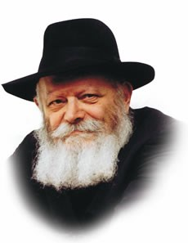

**The Lubavitcher Rebbe, zt”l**

This week's Torah portion, Acharei, begins with the words, "The L-rd spoke to Moses after the death of Aaron's two sons, when they had come close before G-d, and died."

According to our Sages, both Nadav and Avihu were righteous; their failing was that they got so close to G-d that their physical bodies could not withstand the intense holiness. The desire of Nadav and Avihu to merge with G-d was so great that their souls departed, in contradiction to G-d's plan that the soul remain in a body, effecting change in the physical world through Torah and mitzvot.

Aaron's sons are symbolic of a negative type of willingness for self-sacrifice. For, one may never attempt to draw closer to G-d at the expense of one's personal mission in the world, no matter how lofty the motive.

The Talmud relates that "Four people entered the Garden: Ben Azai peeked in and died...Rabbi Akiva entered in peace and went out in peace."

"Entering the Garden" refers to the attempt to attain the highest levels of union with G-d, by delving into the Torah's most esoteric mysteries. Ben Azai's venture was as unsuccessful as Nadav and Avihu's: his extreme thirst for holiness led him to cross a certain forbidden boundary, with the result that he passed away. Rabbi Akiva, however, "entered in peace and went out in peace."

The reason Rabbi Akiva was able to "go out in peace" was because he had "entered in peace." His only motivation in drawing closer to G-d was to fulfill His will. Thus, he was able to navigate successfully when confronted with dangerous choices, with a positive outcome.

Nevertheless, Rabbi Akiva is not symbolic of the highest level of a Jew's desire to fulfill the will of G-d, a position occupied by Abraham, the first Jew. Even though Rabbi Akiva's primary motivation was to obey G-d, he desired to give up his life to sanctify G-d's name (a desire that was ultimately fulfilled when he was tortured to death by the Romans. Right before he died, Rabbi Akiva declared that he had spent his whole life in anticipation of that moment.)

Abraham, on the other hand, never sought this out. All he thought about was G-d; his entire life was devoted to making His name known in the world. If self-sacrifice proved to be necessary he would gladly give up his life, but it was never an end in itself.

From Abraham we learn that our primary concern must always be to fulfill G-d's will, without involving ourselves in the equation. If all our actions are done for the sake of Heaven we are assured that both our "entry" and our "exit" from the Garden will be peaceful, and our service of G-d will be full and complete.

*Reprinted from the Parashat Acharei Mos 5755/1995 edition of L’Chaim Weekly (Issue #263), a publication of the Lubavitch Youth Organization in Brooklyn, NY.*

**Rav Avigdor Miller on**

**Moving Out of the Ghetto**

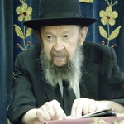

**QUESTION:** The Rav mentioned tonight that we are constantly being tested in this world by our environment. What would be the best plan for us to succeed in overcoming this test?   
 **ANSWER:** First of all, the most important thing is that you must choose your environment. It's of the utmost importance to live among frum Jews. If you want to be the best, you must live among the best!  It's a very great error to move to the suburbs! Like one person who came here, and I said to her, "What about coming to live in Brooklyn?" So she said, "We want to get away from the ghetto."

And that's a terrible sin against the Jewish people. We should seek to be as close as possible to our people. And instead, those who want to get away from the ghetto - that means from the Jewish people - are moving further and further away. And what that means is that they're moving further and further away from Hashem. And closer and closer to *gehenim*.  Some people even moved out to California to get away. And now, even that's too close for them. So they're moving into the Pacific Ocean, to the Philippines. They're running away from the best environment there is.   
 So number one is, associate with frum people. That's the very best way to overcome the tests of the environment. There are more ways than that, but that's number one.

*Reprinted from the April 11, 2019 email of Toras Avigdor (Tape #801).*

**The Shmuz on****Parshas Acharei Mos**

**Systems of Human Perfection**

**By Rabbi Bentzion Shafier**

**Founder of TheShmuz.com**

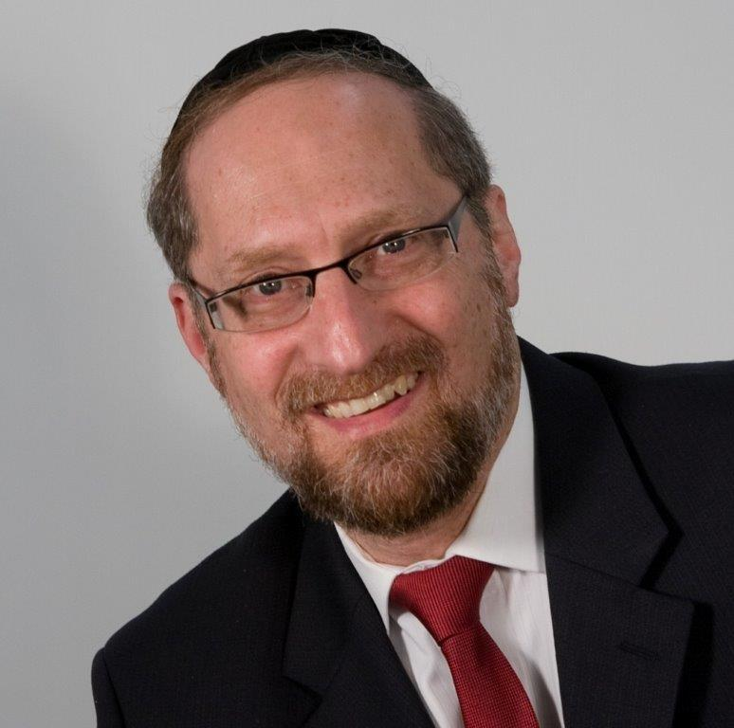

“*And a man from the house of Israel, and from the converts who live with you, who shall consume any blood, I shall place My face against the soul of the one who consumed blood, and I shall cut it off from amongst your nation.*” Vayikrah” 17: 10

The Torah warns us many times and with many different exhortations not to consume blood. The Kli Yakar points out than in Devarim the Torah tells us not to eat blood because “It will be good for you and your children after you”. He explains that: “Consuming blood brings cruelty into the one who eats it, and the nature of the father is given over to his children to be like him. Therefore, the Torah warns us not to consume blood so that we don’t acquire this nature.”

It seems clear from the Kli Yakar that consuming blood will cause a change in the nature of the person who consumes it. His sensitivities and reactions will have changed, and he will become a different person. However, not only will he become callous and pitiless, these traits will become part of his genetic transmission, so that any child that he then has will have this same predisposition towards cruelty.

This concept seems difficult to understand. Firstly, how does consuming blood make a person cruel? Secondly, how does that change affect the very hereditary transmission of a person so that his children will be pitiless as well?

To understand the answer to this, we need to focus on the basic make-up of man.

The Chovos Ha’Levovos (Sha’ar Avodas Elokim 3) explains that HASHEM created man out of two very distinct parts – a nefesh ha’Schili (intellectual soul) and a nefesh Ha’Bahami (animal soul). The “I” that thinks, feels, and remembers is comprised of two separate and competing parts, each one with its own nature, tendencies, and needs. The nefesh ha’Schili desires only that which is good, right, and noble. It yearns to help others, it hungers for meaning and purpose, and more than anything, it needs to be close to HASHEM.

Then there is the other part of man — the animal soul. It too has desires and inclinations, and it too hungers for things. One way to better understand the animal soul in man is to visit its parallel in the wild kingdom.

**Understanding the Nefesh Ha’Bahami**

HASHEM imprinted into the essence of each animal all the instincts necessary for its survival as well as for the continuation of its species. The animal doesn’t have a cognitive, reasoning element. It doesn’t have an “I” that is the master of the ship. But it does have a vibrant essence that is programmed to seek out its needs. That part is the nefesh of the animal.

That nefesh is pure instinct, drives, and passions, and is affected by both internal and external triggers. In the spring, birds fly north and engage in a fury of nest-building and mating. The individual bird doesn’t purposefully choose its mate. Two robins don’t sit down and say to each other, “It’s time for us to settle down and raise a family.” The animal is attracted by the sight, smell, and sound of one of its species, and then will hotly pursue it – often becoming bonded for life. It is driven by instinct in a preset pattern.

Those instincts and desires are affected by various forces. A bird from a different species will not elicit the mating response, nor will even the same bird in a different time of the year. In the dead of winter, these desires lay dormant. The change in season brings them forward to the extent that they take over the existence of that bird. They have been pre-programmed to respond to stimuli that allow for the success of the individual bird and the species as a whole.

**The Answer to the Kli Yakar**

This seems to be the answer to the question. The Kli Yakir is teaching us that when the Torah forbids us to eat blood, it is because consuming it would make a dramatic change in our inner essence. We would be ingesting part of the nefesh of that animal, and it would become part of our own Nefesh Ha’Bahami. Our conscious reality would change because part of who we are is the animal soul, and we would thereby acquire cruelty. This change is so potent that if the person who drank that blood were to then have a child, that child would also have cruelty as part of his inner make-up.

Much like certain chemicals can affect a man’s mood; the Torah is teaching us that there are some properties that have a permanent effect on the nature of man. They change his Nefesh, and that changes the way that he thinks and feels.

Similarly, the mefarshim explain to us that none of the kosher animals are predators. The nature of a predatory animal is to hunt down and kill. If a person were to consume meat from such an animal, some part of the Nefesh of that animal would enter into man’s soul and he would acquire an aggressive, violent nature. The Torah forbids it because it would damage the fine balance in man.

This concept is very significant as it helps us better understand the Torah as the system of human perfection. HASHEM is the Creator, and He wrote the Torah as the guidebook for human growth. Contained within it are all the tools necessary to reach greatness. Some of the tools are easily understood and some takes years to fully comprehend, but the system is there. By following the guidelines, restrictions, and commandments, a person guarantees that he is headed in the right path – using his stay on the planet to grow and perfect himself.

*Reprinted from this week’s website on TheShmuz.com This is an excerpt from the [Shmuz on the Parsha book](https://theshmuz.com/product/shmuz-on-the-parsha-book/).*